Frederick Costello
CSD-325
3/26/2026
Using PyCharm IDE.

Pic 1. Creating breaking point…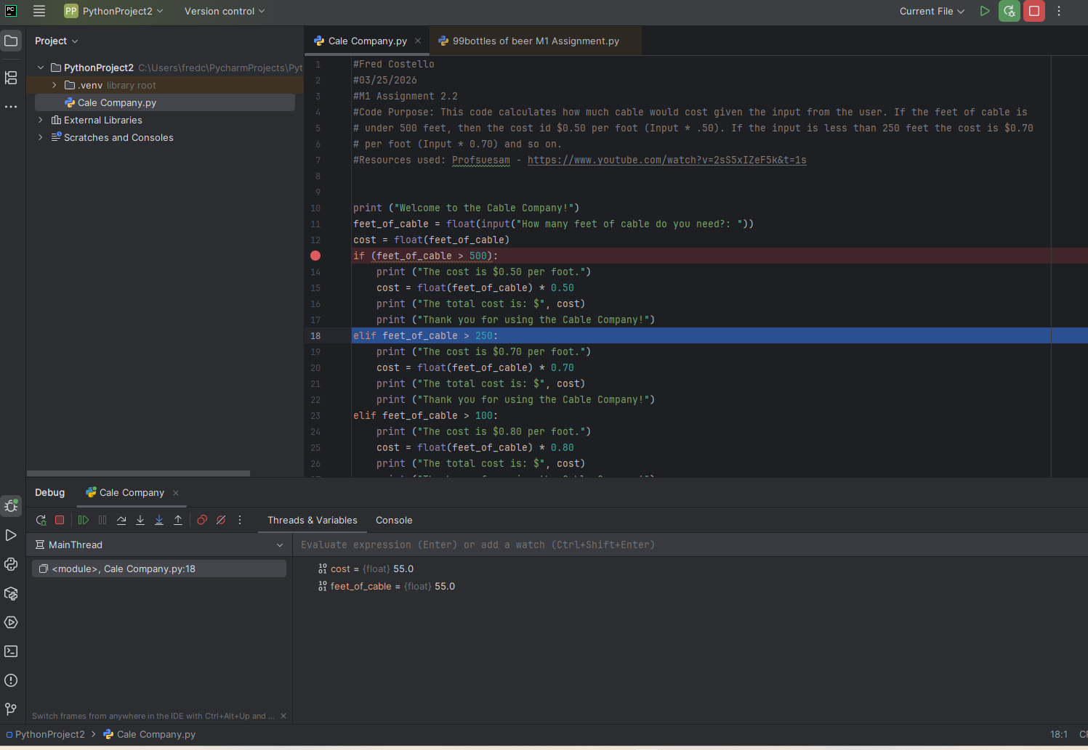
Pic 2. Stepping into program (step down and debug menu in red pen, lower left).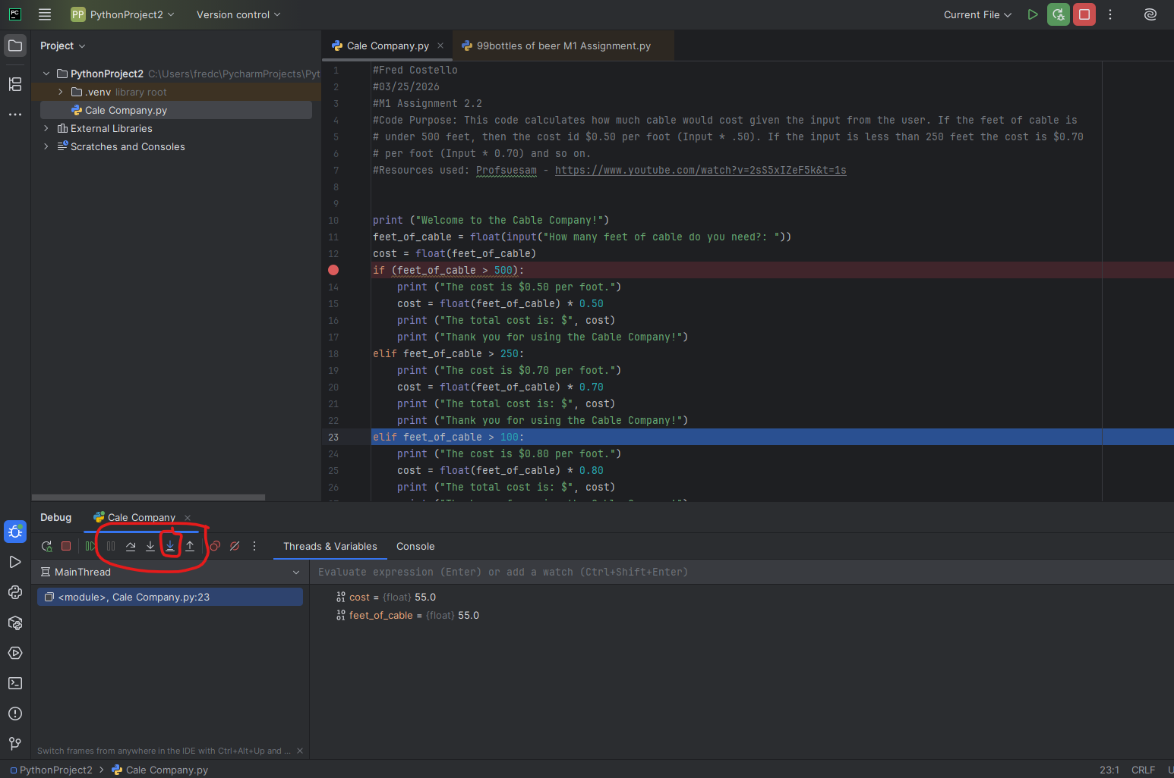

Pic 3. Intentional error expression on Line 15.
